The Turing machine M has:
- States q and p; q is the start state
- Tape symbols 0, 1 and B; 0 and 1 are inputs symbols, and B is the blank.
- The following next-move function:
State | Tape Symbol | Move
q | 0 | (q, 0, R)
q | 1 | (p, 0, R)
q | B | (q, B, R)
p | 0 | (q, 0, L)
p | 1 | None (halt)
p | B | (q, 0, L)

TURING MACHINE DIAGRAM:
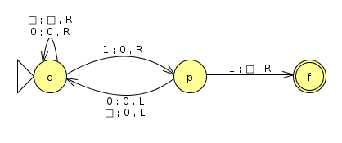Turing machine

SIMULATION RESULTS:
A) String: 1001
q1001 ⊢ 0p001 ⊢ q0001 ⊢ 0q001 ⊢ 00q01 ⊢ 000q1 ⊢ 0000p ⊢ 000q00 ⊢ 0000q0 ⊢ 00000q ⊢ 00000Bq ⊢ 00000BBq ⊢ ... ⊢ 0⁵B∞q
B) String: 11010
q11010 ⊢ 0p1010 ⊢ halt
C) String: 0010
q0010 ⊢ 0q010 ⊢ 00q10 ⊢ 000p0 ⊢ 00q00 ⊢ 000q0 ⊢ 0000q ⊢ 0000Bq ⊢ 0000BBq ⊢ ... ⊢ 0⁴B∞q
D) String: 001010
q001010 ⊢ 0q01010 ⊢ 00q1010 ⊢ 000p010 ⊢ 00q0010 ⊢ 000q010 ⊢ 0000q10 ⊢ 00000p0 ⊢ 0000q00 ⊢ 00000q0 ⊢ 000000q ⊢ 000000Bq ⊢ 000000BBq ⊢ ... ⊢ 0⁶B∞q

